
Air Aware Smart Air Quality Prediction System

Project Title: AirAware - A Smart Air Quality Forecasting and Analysis System

Project Purpose :
- A forecasting system that predicts AQI and major pollutants, analyzes pollutant contributions and seasonal trends, and provides alerts when air quality crosses unsafe levels.
- An interactive dashboard with admin functionality to upload new datasets, view historical and future trends, and retrain models for updated forecasting.
Intern: Mr. Shiven Poojary

Mentor : Ms. Asma Mam

Techonologies Used : Python,Streamlit

Date: 18th November 2025

Project Purpose
The Smart Air Quality Analysis Suite is an end-to-end data science platform for analyzing, forecasting, and monitoring air quality. The system is implemented as a series of distinct, interoperable Streamlit applications, each corresponding to a critical phase of the data science lifecycle:
- Exploratory Data Analysis (EDA)
- Model Prototyping & Experimentation
- Real-time Monitoring & Reporting
- Production Model Training & Deployment
The suite is designed to transform raw air quality data into actionable insights, health alerts, and robust predictive forecasts.

System Components
The suite consists of four primary modules:
- Milestone 1: Data Explorer (Dashboard1.py)
  - A dashboard for initial exploratory data analysis (EDA) of the raw dataset.
- Milestone 2: Forecast Engine (Dashboard2.py)
  - An advanced model-prototyping environment for in-memory training and comparison of Prophet, ARIMA, and LSTM models.
- Milestone 3: AQI Alert System (Dashboard3.py)
  - A real-time monitoring dashboard that calculates the Air Quality Index (AQI) and generates alerts and PDF reports.
- Milestone 4: AI/ML Dashboard (Dashboard4.py)
  - An operational (MLOps) dashboard with two modes:
    - Admin Mode: For training a suite of models, evaluating them, and saving the optimal model to disk.
    - User Mode: For loading the pre-trained, production-ready model to serve forecasts to end-users.
Installation & Configuration

1. Prerequisites
- Python 3.8+
- pip (Python package installer)

2. Dependencies
Install all required libraries using the provided requirements.txt file.
requirements.txt
streamlit
pandas
numpy
altair
matplotlib
plotly
scikit-learn

statsmodels
prophet
tensorflow
xgboost
reportlab
joblib
Installation Command:
Bash : pip install -r requirements.txt

3. Project Configuration
- Data Files: Place data.csv and human_readable_air_quality_CITYWISE.csv in the root directory of the project.
- Model Directory: The AI/ML Dashboard (Module 4) requires a directory to save and load trained models. Create this directory in the project root:
Bash : mkdir models

Module Specifications

1. Module 1: Data Explorer (Dashboard1.py)
- Objective: Perform initial exploratory data analysis.
- Data Source: data.csv
- Key Functionality:
  - Data Filtering: By Location and Time Range (Last 90 Days, Last Year, All Time).
  - Visualizations:
    - Time Series: st.line_chart for selected pollutant trends.
    - Statistical Summary: Key metrics (mean, median, std dev) via st.metric.

    - Correlation: st.scatter_chart to visualize correlation strength between pollutants.
    - Distribution: st.bar_chart (histogram) to show the frequency of pollutant levels.
- To Run: streamlit run Dashboard1.py

2. Module 2: Forecast Engine (Dashboard2.py)
- Objective: Prototype and compare advanced time-series models in-memory.
- Data Source: human_readable_air_quality_CITYWISE.csv
- Algorithms: Prophet, ARIMA (from statsmodels), LSTM (from tensorflow.keras).
- Key Functionality:
  - Model Comparison: Trains and evaluates all selected models on an 80/20 train/test split.
  - Performance Metrics: Displays RMSE and MAE for all models in a comparative bar chart.
  - Forecast Visualization: Overlays model predictions on the test set to visually inspect performance.
  - Horizon Accuracy: Calculates and plots model RMSE over increasing forecast horizons (1, 3, 7, 14, 30 days) to test long-range stability.
  - Caching: Uses @st.cache_resource to persist trained models in memory, allowing for UI updates without re-training.
- To Run: streamlit run Dashboard2.py

3. Module 3: AQI Alert System (Dashboard3.py)
- Objective: Provide real-time AQI monitoring, health alerts, and reporting.
- Data Source: data.csv
- Key Functionality:
  - AQI Calculation: Implements a CPCB-compliant (Central Pollution Control Board) algorithm to calculate sub-indices for PM2.5, PM10, SO2, and NO2, and determine the final AQI.
  - Real-time Gauge: A plotly.graph_objects.Indicator gauge displays the most recent AQI value and its corresponding health category (e.g., "Good," "Moderate," "Severe").
  - Health Alerts: Dynamically generates alerts based on current AQI levels.
  - PDF Report Generation: Uses the reportlab library to generate a downloadable PDF summary of the current air quality status, including filtered data tables.
- To Run: streamlit run Dashboard3.py

4. Module 4: AI/ML Dashboard (Dashboard4.py)

- Objective: Operationalize the ML workflow by training, saving, and serving the best-performing model.
- Data Source: data.csv
- Key Functionality:
  - Admin Mode:
    - Workflow: Activated via a sidebar checkbox.
    - Training: Trains a suite of models (XGBoost, Prophet, ARIMA, LSTM).
    - Evaluation: Compares all models on a validation set (using MAE/RMSE).
    - Deployment: Selects the single best-performing model and serializes it (using joblib) to the /models directory (e.g., models/Hyderabad__pm2_5__best.joblib).
    - Allow users to upload their own CSV and retrain models via the UI.
    - Model Persistence : App saves the best models (.joblib files) so they don't need to retrain every time. This is "Optimization."
  - User (Forecast) Mode:
    - Workflow: This is the default mode.
    - Loading: On startup, the dashboard loads the pre-trained .joblib model from the /models directory for the selected location and pollutant.
    - Forecasting: Uses the loaded model to generate a forecast for the specified horizon (e.g., 24, 48 hours). If no model exists, it uses a naive forecast (last value).
    - Visualization: Displays the historical data and the loaded model's forecast in a single, continuous Plotly chart.
- To Run: streamlit run Dashboard4.py

Data Model
- data.csv
  - Description: The primary, raw, granular dataset. Contains multiple readings per day for numerous locations.
  - Key Columns: stn_code, sampling_date, state, location, type, so2, no2, rspm (PM10), spm, pm2_5, date.
  - Usage: Used by Modules 1, 3, and 4 for analysis, monitoring, and production training.
- human_readable_air_quality_CITYWISE.csv
  - Description: A pre-cleaned and aggregated dataset, likely with daily averages and fewer missing values.
  - Key Columns: date, location, avg_rspm, avg_so2, avg_no2, Air_Quality_Status.
  - Usage: Used by Module 2 for rapid prototyping and model comparison, as it requires less on-the-fly cleaning.

Limitations & Assumptions
This section is crucial for professional documentation as it defines the project's boundaries and manages stakeholder expectations.
- Data Dependency: The system's performance is entirely dependent on the quality, granularity, and consistency of the input CSV files (data.csv, human_readable...csv). It does not include automated data ingestion from live APIs or databases.
- Model Generalization: The models trained by Module 4 are specific to the location and pollutant they were trained on. They will not generalize to other cities without being re-trained on that city's data.
- Static Model Training: The "Admin Mode" in Module 4 requires manual intervention to re-train models. The system does not currently support automated re-training or MLOps (e.g., detecting model drift and triggering a new training pipeline).
- Stateful Environment: The dashboards are Streamlit applications, which are not inherently designed for high-concurrency, multi-user production environments without additional infrastructure.
- Assumptions:
  - It is assumed that the input data (data.csv) has been sufficiently pre-processed or is of high enough quality for model training.
  - It is assumed that the column names for pollutants (e.g., pm2_5, rspm) are consistent.

Future Work & Scalability
This demonstrates strategic vision for the project's evolution.

1. Recommended Enhancements
- Automated Data Pipeline: Replace static CSVs with a robust data ingestion pipeline (e.g., using Apache Airflow) to pull data from live air quality APIs or a central database (like a Time-Series DB, e.g., InfluxDB).
- MLOps Integration: Integrate a CI/CD pipeline and an MLOps platform to:
  - Model Versioning: Track all trained model artifacts and their performance.
  - Drift Detection: Monitor live data for concept drift and trigger alerts or re-training when model performance degrades.
- Deploying AirAware in an IoT Ecosystem:
- Microcontroller/Gateway : Collects sensor data, pre-processes it, and transmits it to the cloud. (e.g., Raspberry Pi, etc)

2. Scalability
- Database: Migrate from CSV files to a scalable database (e.g., PostgreSQL with the TimescaleDB extension) to handle billions of data points.
- Compute: For Module 2 and Module 4, model training could be offloaded from the Streamlit app to dedicated (and more powerful) cloud-based compute instances (e.g., AWS EC2, Google AI Platform) to prevent the dashboard from freezing during heavy computation.
- Serving: The Streamlit applications can be containerized using Docker and deployed on a scalable platform like Kubernetes (K8s) or a PaaS (e.g., Streamlit Community Cloud, Heroku, AWS Elastic Beanstalk) to handle increased user traffic.

User Manual
This section provides step-by-step instructions for using each application in the suite.

1. Dashboard 1: Air Quality Data Explorer
Goal: Analyze historical trends and find correlations in the raw data.
Step-by-Step Instructions:
- Select Location: Go to the Sidebar (left panel). Use the "Location" dropdown to pick a specific city (e.g., Hyderabad).
- Set Time Range: Choose how much history you want to see (e.g., "Last Year of Data").
- Choose Pollutants:
  - Main Pollutant: Select the primary pollutant (e.g., PM10) to see its specific Time Series graph and histogram.
  - Correlation Pollutants: Select two or more pollutants (e.g., NO2 and SO2) to see if they rise and fall together.
- Run Analysis: Click the green "Apply Filters" button in the sidebar.
- Interpret Results:
  - Top Left: View the line chart to see if pollution is increasing over time.
  - Top Right: Check the "Correlation" scatter plot. If the dots form a diagonal line, the pollutants are related.
  - Bottom Right: Look at the Histogram to see the most common pollution levels.
- Screenshot :

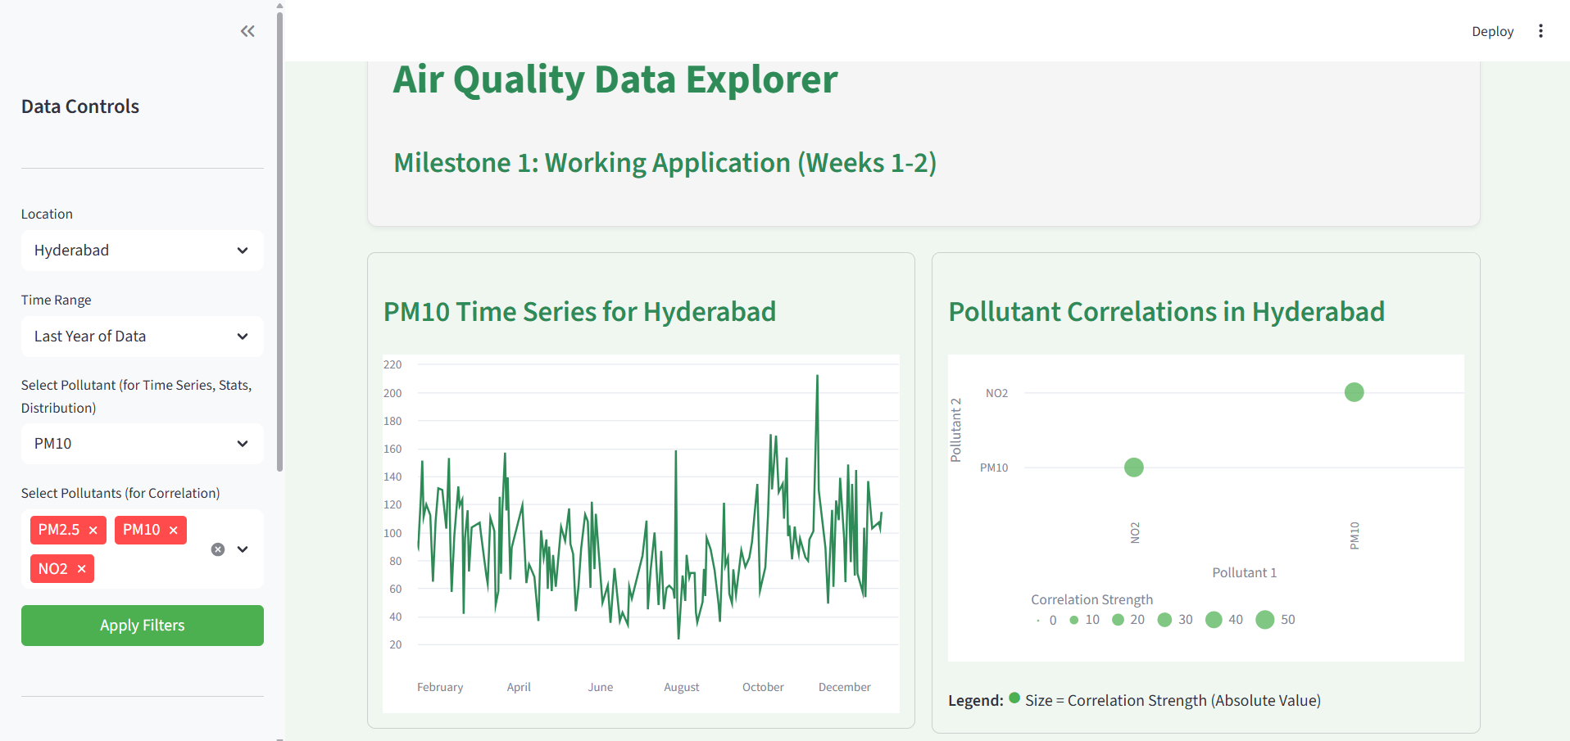

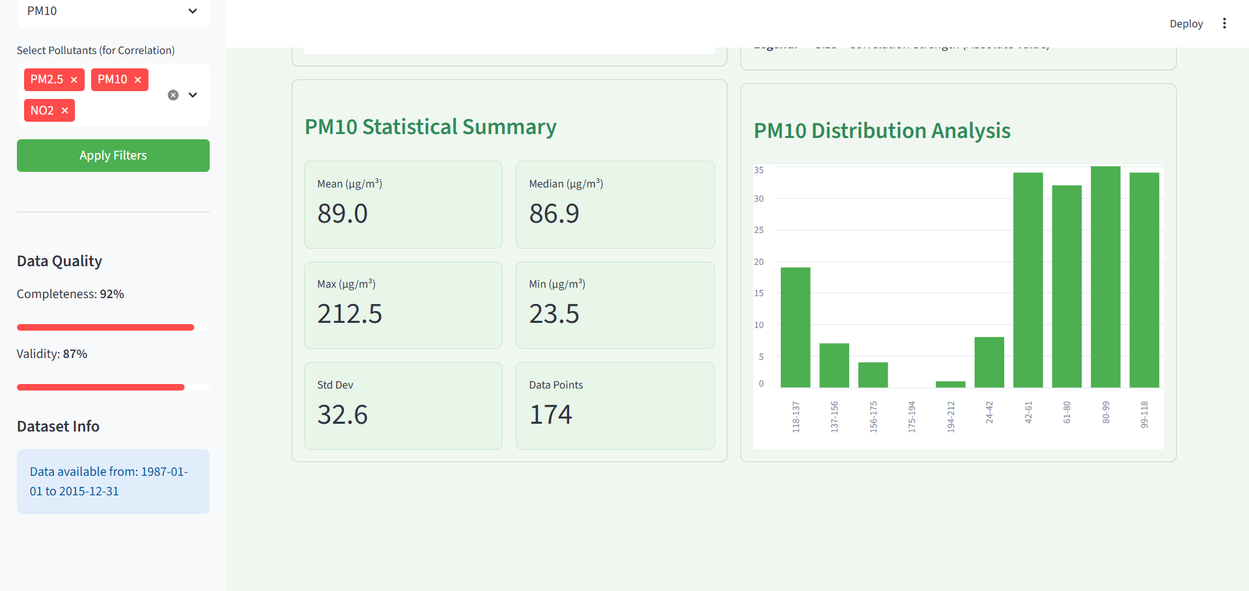

2. Dashboard 2: Forecast Engine
Goal: Compare different AI models to see which one predicts best.
Step-by-Step Instructions:
- Setup (Sidebar):
  - Select City: Choose a city from the clean dataset list.
  - Select Pollutants: Pick what you want to predict (e.g., avg_rspm).
  - Select Models: Check the boxes for Prophet, ARIMA, and LSTM.

- LSTM Settings (Optional):
  - If you want a quick result, check "⚡ Quick Mode" in the sidebar.
  - For higher accuracy (but slower speed), uncheck Quick Mode and increase "LSTM Epochs" to 50 or 100.
- Run Engine: The app runs automatically when you change settings. Watch the progress bar at the top.
- Interpret Results:
  - Top Left (Bar Chart): Look for the shortest bar. Shorter bar = Lower Error (Better Model).
  - Top Right (Line Chart): See which dashed line (prediction) follows the solid blue line (actual data) most closely.
  - Bottom Left (Table): This table explicitly tells you which model won (e.g., "Best Model: LSTM").
- Screenshots:
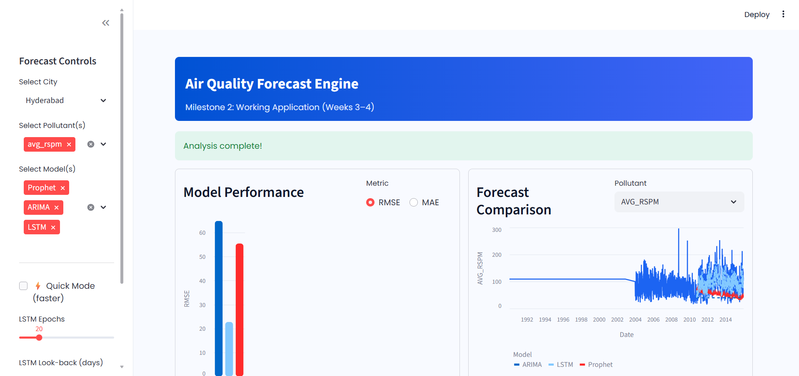

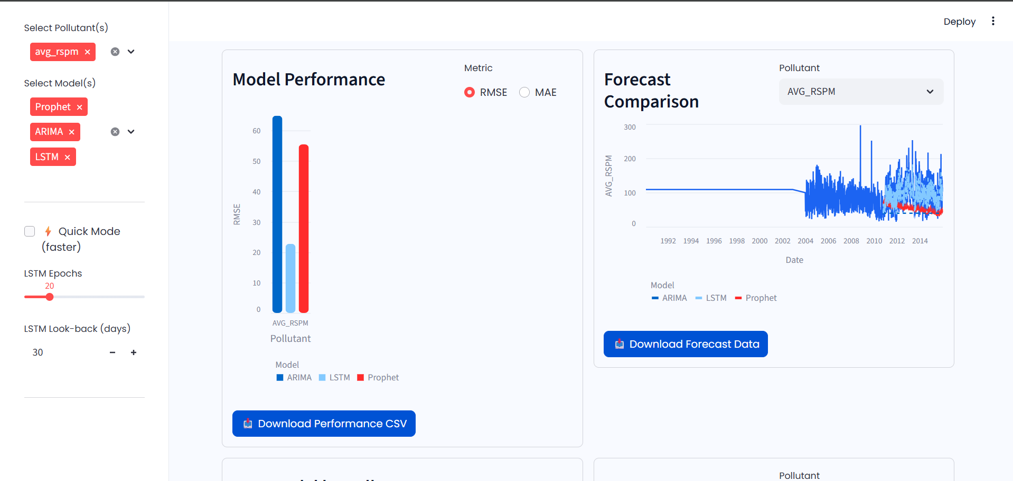

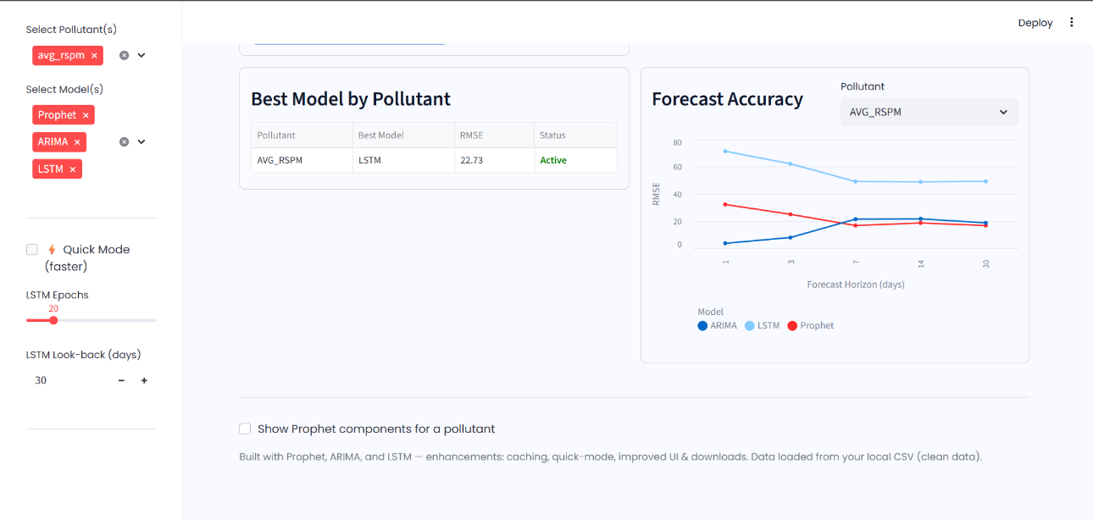

3. Dashboard 3: Alert System & Reports
Goal: Monitor current health status and generate official reports.
Step-by-Step Instructions:
- Filter Data (Sidebar):
  - Select the State and Location.
  - Adjust the Date Range to focus on a specific period (e.g., last week).
- Check Health Status:
  - Look at the big Gauge in the top left.
    - Green: Good air.
    - Red/Maroon: Severe pollution.
  - Read the "Active Alerts" box next to the chart. It will tell you if you need to avoid outdoor exposure.
- View Forecast: Check the "7-Day Forecast" pills on the top right to see the predicted air quality for the coming week.
- Generate Report:
  - Scroll to the bottom of the page.
  - Click "Generate PDF Report".
  - Wait a moment, then click "Download PDF report" to save a summary file for your records.
- Screenshots :

.
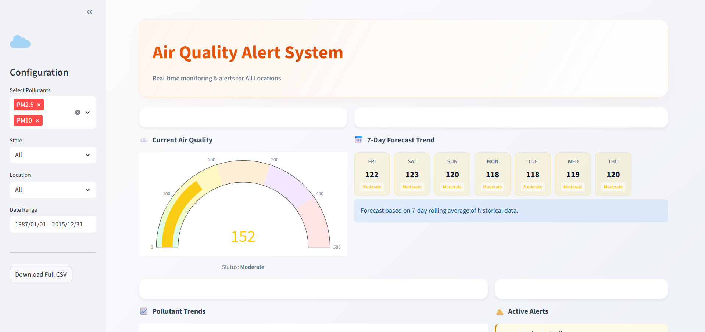

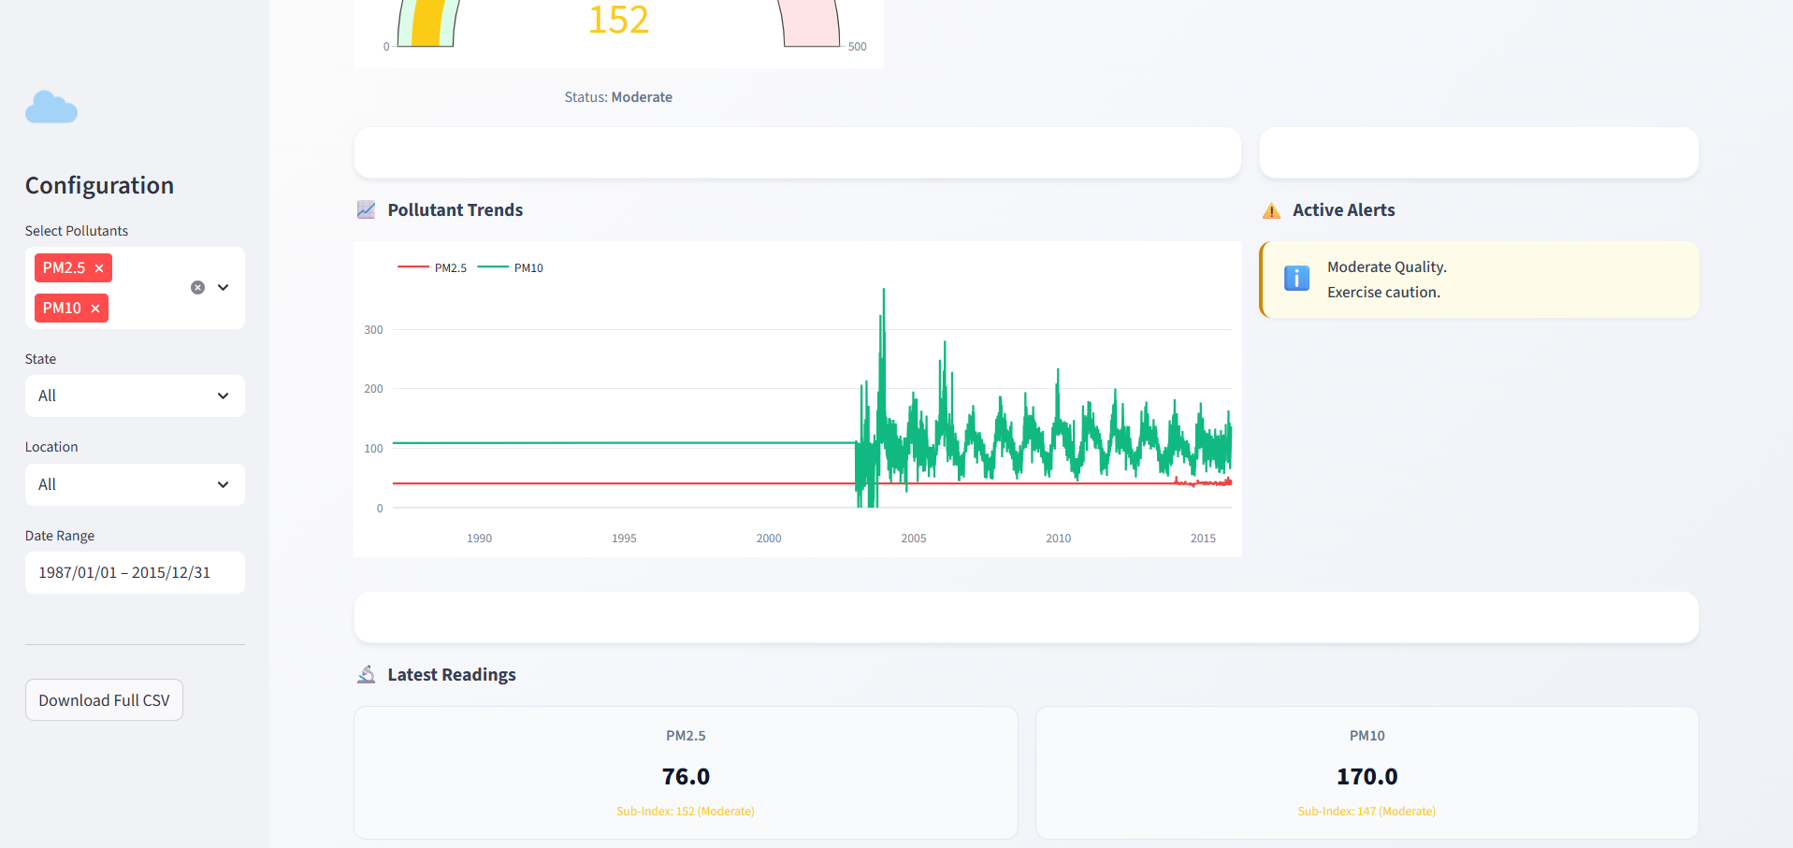

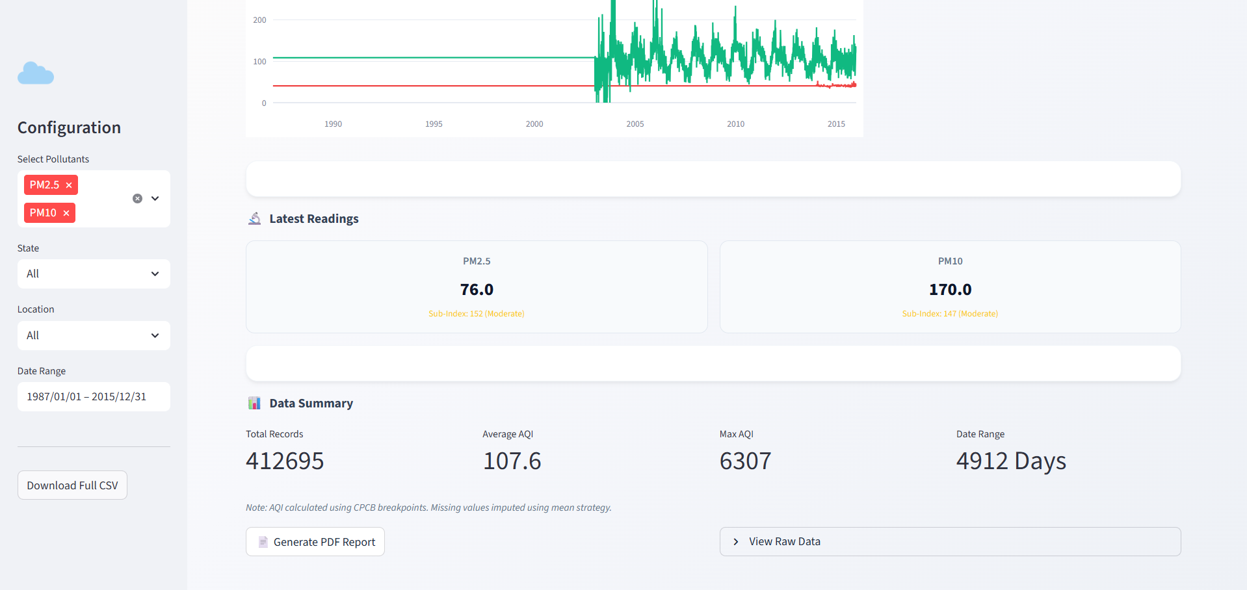

4. Dashboard 4: AI/ML Dashboard (The Main App)
Goal: Train models (Admin) and view future predictions (User).

Mode A: User Mode (Default)
Use this to see the forecast.
- Select Station: Choose your city in the sidebar.
- Select Pollutants: Pick the pollutants you want to track.
- Select Horizon: Choose how far into the future you want to see (e.g., "72 Hours").
- View Forecast:
  - The main chart shows history (solid line) + future prediction (dots/lines).
  - Alerts: If the prediction crosses a danger threshold (e.g., >200), a red warning box will appear at the top.

- Deep Dive: Click the "Pollutant Details" tab to see hourly trends (e.g., does pollution spike during rush hour?).
- Screenshots :

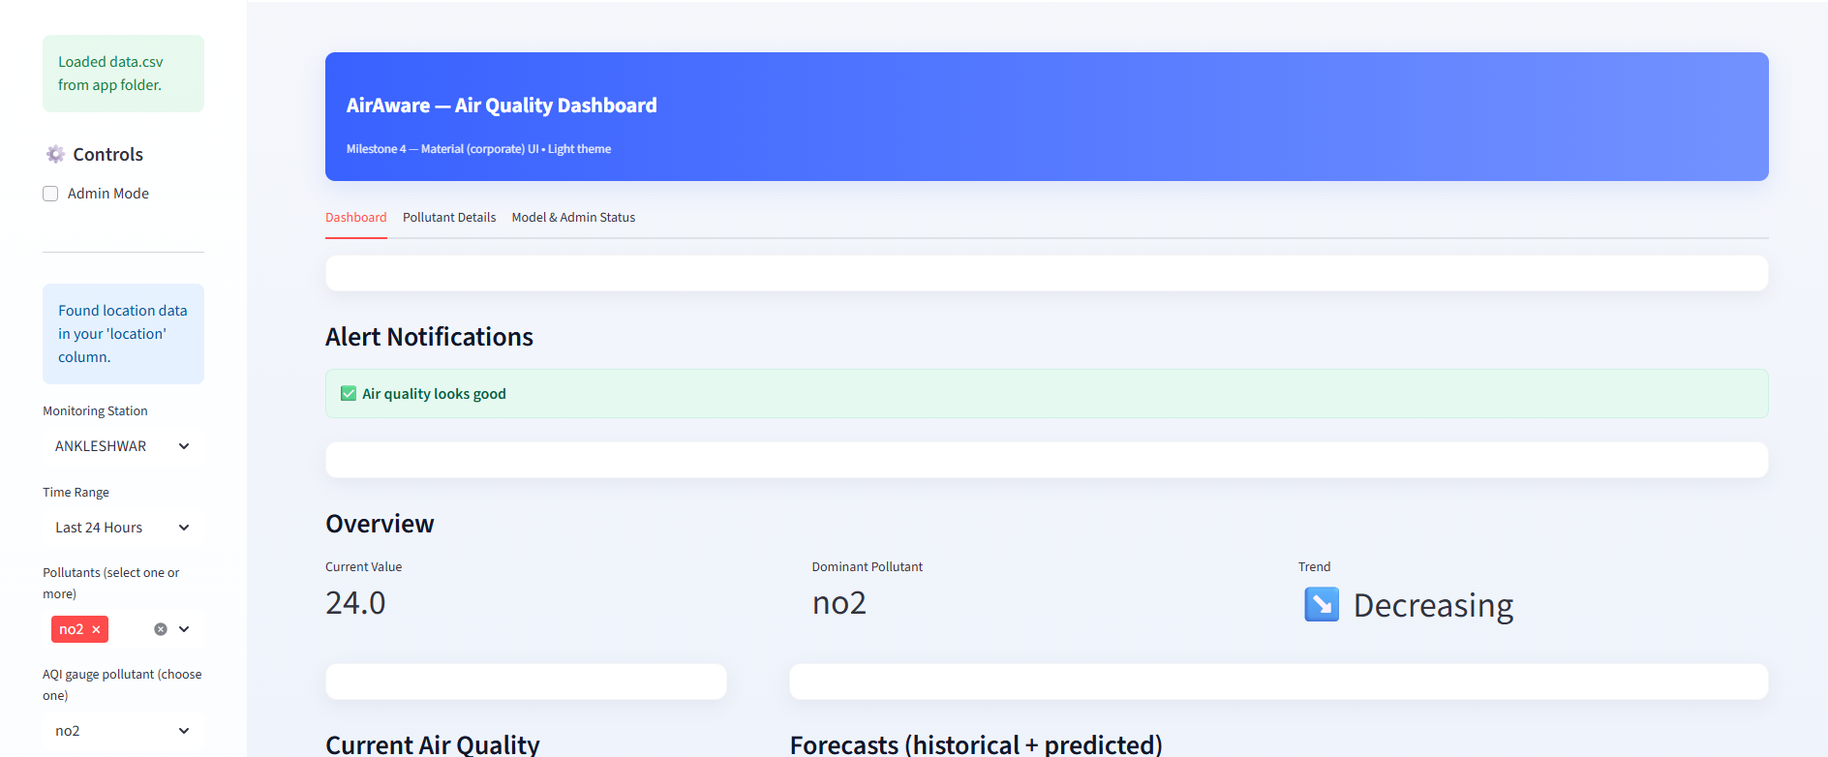
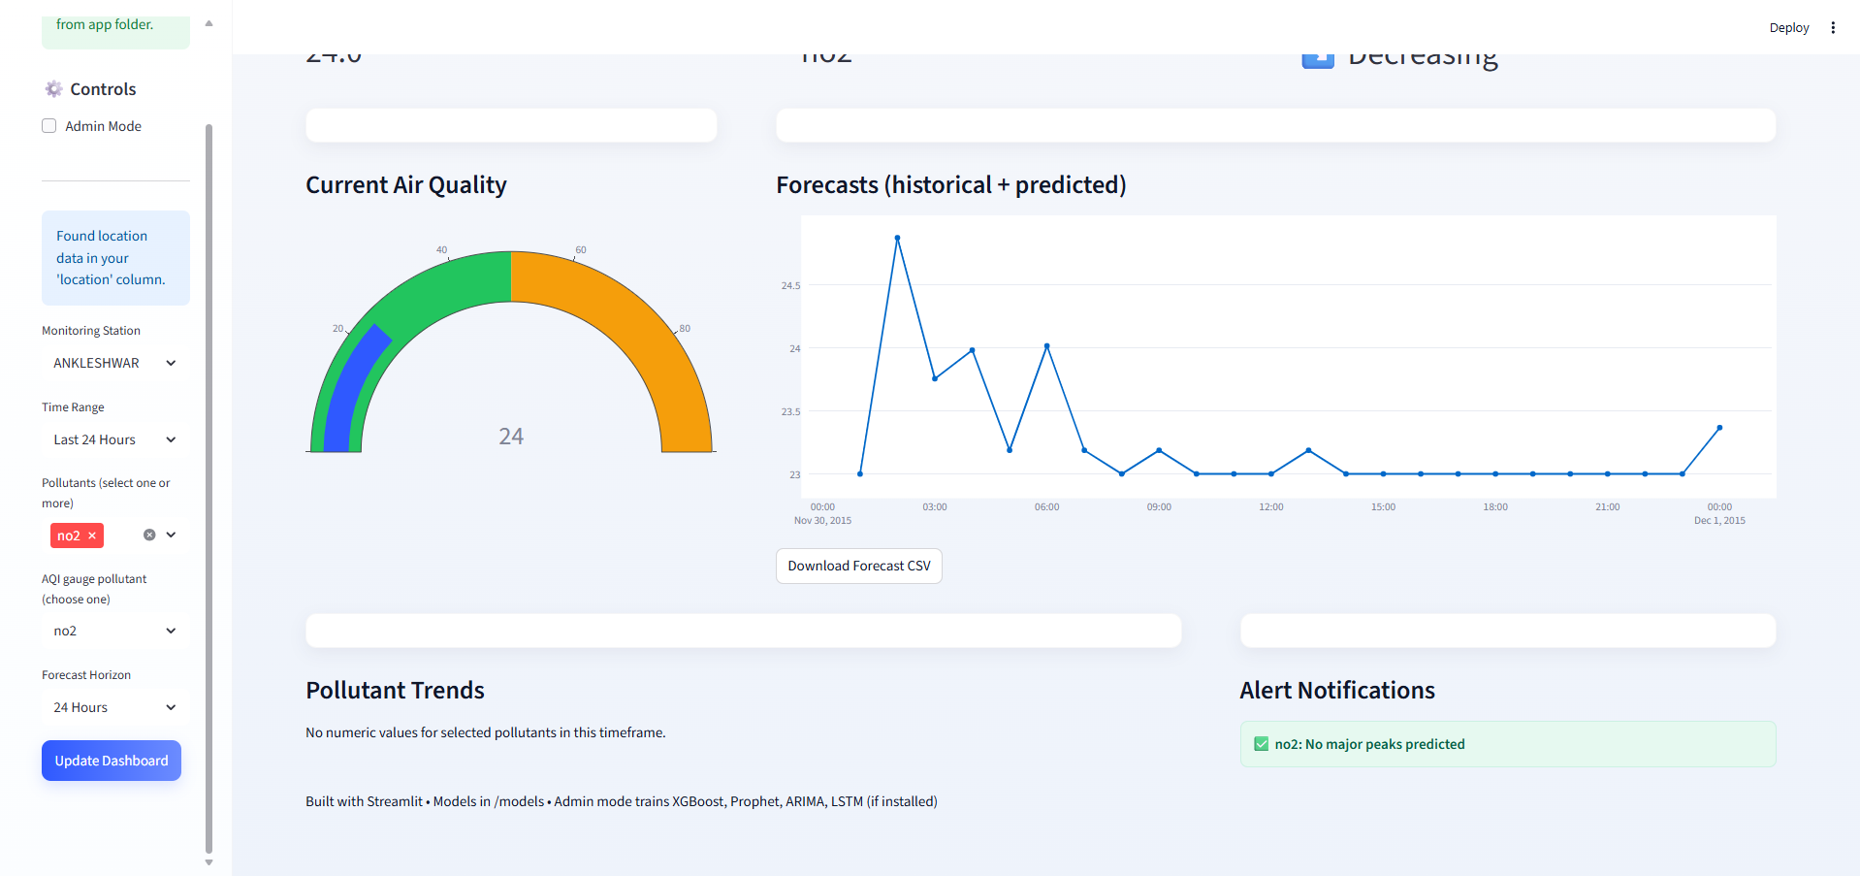
.Mode B: Admin Mode (Training)
Use this only when you want to create NEW models.
- Activate: Check the "Admin Mode" box in the sidebar.
- Upload Data: If you have a new dataset, upload the CSV file here.
- Configure Training:
  - Select the City and Pollutants you want to train for.
  - (Optional) Increase LSTM Epochs for better accuracy.
- Train: Click the "Train best models..." button.
  - Wait! This process takes time. The app will try XGBoost, Prophet, ARIMA, and LSTM for every pollutant.
  - Watch the sidebar logs. It will say "Saved best model..." when finished.

- Download Models: Once finished, a "Download .zip" button will appear. You can download the trained models to share them.
- Screenshots :
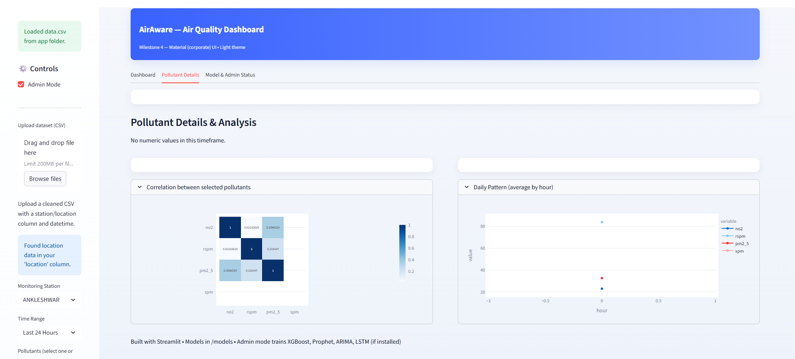

(*Note : This dataset doesn’t consists of hourly data due to which daily pattern might not be visible)
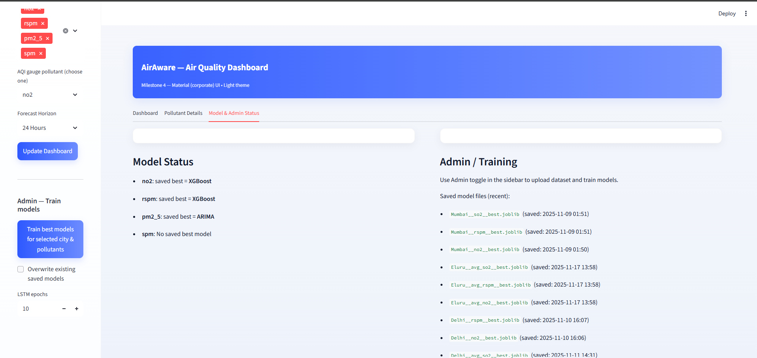

Conclusion
The Smart Air Quality Analysis Suite represents a comprehensive, end-to-end solution for air quality data science. It successfully bridges the gap between raw data exploration, rigorous model prototyping and real-time monitoring.
By segmenting the workflow into four distinct, high-functioning modules, this project provides a specialized tool for each stage of the data lifecycle. It effectively transforms raw, unprocessed data into a deployable, intelligent forecasting system and a real-time, actionable alert mechanism.
This suite serves as a powerful proof-of-concept and a robust foundation for a production-grade environmental intelligence platform. The architecture is designed for future expansion, ready to be scaled and integrated with automated data pipelines and more advanced cloud infrastructure.

